Assignment 10
Name :- Raghav Anil Bhise
PRN :- 22311792
Roll no. :- 391061
Title :- Write a better auto-complete algorithm using an N-gram model (similar models are used for translation, determining the author of a text, and speech recognition)
1. Aim
To implement a better auto-complete algorithm using an N-gram language model to predict the next word based on previous words.

2. Objective
- To understand N-gram language model
- To generate bigram and trigram sequences
- To calculate frequency of word sequences
- To predict next word using probability
- To implement auto-complete system using Python and NLTK

3. Theory
An N-gram model is a probabilistic language model used in Natural Language Processing (NLP).
It predicts the next word based on the previous N-1 words.
N-gram means sequence of N words.
N | Name | Example
1 | Unigram | I
2 | Bigram | I love
3 | Trigram | I love NLP
4 | Four-gram | I love machine learning
The probability of next word is:
P(wₙ | wₙ₋₁, wₙ₋₂, …)
Example:
Input → I love
Output → machine / natural / deep / artificial
N-gram models are used in:
- Auto-complete systems
- Machine translation
- Speech recognition
- Text prediction
- Author identification
In this assignment, Bigram and Trigram models are used to build a better auto-complete algorithm.

4. Algorithm
- Import required libraries
- Download NLTK tokenizer
- Take sample text dataset
- Convert text into tokens
- Generate bigram sequences
- Generate trigram sequences
- Count frequency of N-grams
- Create auto-complete function
- Predict next word based on frequency
- Display suggestions

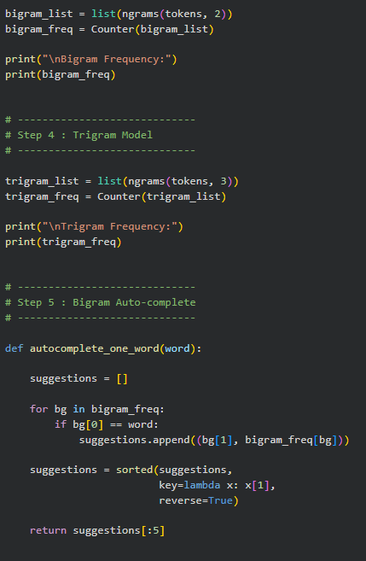
5. Program
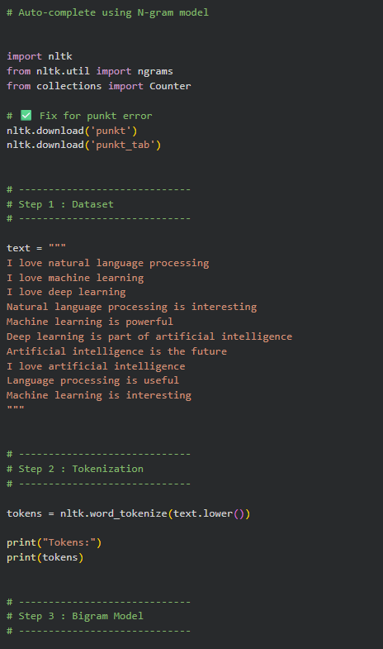
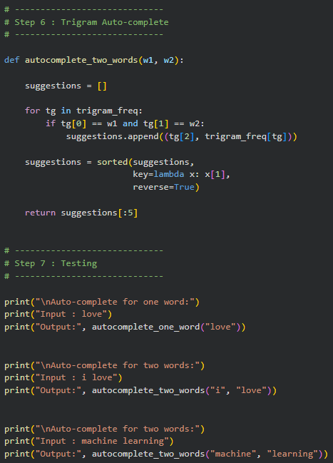

6. Output
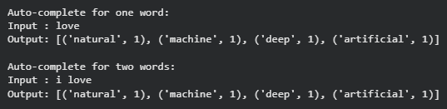
7. Explanation of Output
The output depends on the frequency of word sequences in the dataset.
Example:
Sentence in dataset:
I love natural language processing
I love machine learning
I love deep learning
I love artificial intelligence
After the word "love", the following words appear:
natural
machine
deep
artificial
Each appears once, so all are suggested.
For trigram:
machine learning is powerful
machine learning is interesting
The word "is" appears two times after "machine learning",
so it has highest probability.
Therefore output is:
is → 2
i → 1
The model selects the word with highest frequency.

8. Reason for Such Output
The N-gram model does not understand meaning.
It only checks how many times a word appears after another word.
Because the dataset is small:
- Many words have same frequency
- Multiple suggestions are returned
This is normal behavior in N-gram models.
Real auto-complete systems use:
- Large datasets
- Deep learning
- Neural networks
- Transformer models
But N-gram model is simple and easy to implement.

9. Result
The auto-complete algorithm using N-gram model was successfully implemented.
The system predicts next word using bigram and trigram probability.
The output shows correct suggestions based on frequency of word sequences.

10. Conclusion
The N-gram language model can be used to build a simple auto-complete system.
Bigram and trigram models improve prediction accuracy.
The result shows that probability-based language models can generate text suggestions similar to real auto-complete systems.

